**Learn to use your "other" hand**

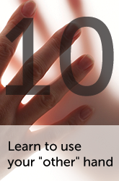

**The task:** If you're right-handed, use your left hand for daily activities (or vice-versa). Start with brushing your teeth left-handed, and practice until you have perfected it. Then try to build your way up to more complex tasks, such as eating.

**The reason:** This is an exercise in which you know what you're supposed to achieve, but must do it in a new and demanding learning context. Doing such an activity can drive your brain to make positive changes. Think of millions of neurons learning new tricks as you finally establish better control of that other hand!

**Catch some Z's**

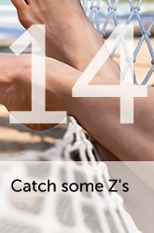

**The task:** Get a good night's sleep. If you have trouble falling asleep, make sure your bedroom is quiet and dark, learn some deep relaxation techniques, and avoid alcohol and caffeine after 7 in the evening.

**The reason:** Scientists believe that our brains consolidate learning and memories during sleep. Studies have shown that people who don't sleep enough have more trouble learning new information, while sleeping well after learning something new helps the brain effectively put that information into long-term memory.

**Get exercise**



**The task:** Brain health is another reason to get on your bicycle, to the swimming pool or wherever else you like to exercise your body.

**The reason:** New research indicates that exercise has positive benefits for the hippocampus, a brain structure that is important for learning and memory. It can even help your brain create new cells.